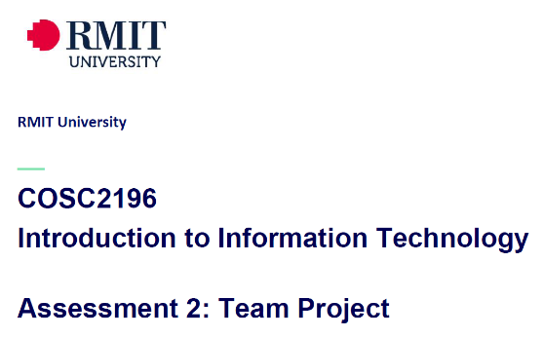 **A2, Group #4 MEETING**

**Venue:** Online via MS Teams

**Date: 6-4-21**

**Agenda**

**Meeting Opened: (time)**

**Attendance: Paul Eccarius, Rebecca Watson, Martin Lee, Nour Zeroual, Jarrad Hofman-Agar**

**Apologies:**

1. **Minutes from previous Meeting -**

* **Actions arising as per Action Register**

|  |  |  |  |  |  |
| --- | --- | --- | --- | --- | --- |
| Meeting Date | Action | Who to action | Completed Y/N | Update at meeting | Further action |
| 31/3/21 | Team Name! | Everyone |  | 5/4/21 |  |
| 31/3/21 | Profile & IT Jobs Collation | Rebecca |  | 5/4/21 |  |
| 31/3/21 | Github & Archiving | Paul |  | 5/4/21 |  |
| 31/3/21 | Interview Questions & Appointment | Nour |  | 5/4/21 |  |
| 31/3/21 | Industry Information – Revist on 5/4/21 | Team |  | 5/4/21 |  |
| 31/3/21 | IT Technologies Report:    Martin: Cybersecurity  Rebecca: Cloud Services  Nour: Machine Learning  Paul: Raspberry Pi etc. | Team |  | 5/4/21 |  |
| 31/3/21 | Project Ideas | Team |  | 5/4/21 |  |

1. **Correspondence:**

5-4-21 – Umera has responded to Bec via email with the following:

Did you receive any response from Anthony Middleton?  
Can you forward me the copy of email you sent out to him?  
  
Kind Regards,  
Umera

Bec has replied by forwarding email again to Umera sent on 29-3-21 to Anthony and advising no response from this person to the group.

1. **Team Profile**
2. **Ideal Jobs**
3. **Tools**
4. **Industry Data**
5. **IT Work**
6. **IT Technologies**
7. **Project Ideas**
8. **Additional points for discussion?**

**Next meeting date:**

**Meeting closed: (time)**

**Actions Register**

|  |  |  |  |  |  |
| --- | --- | --- | --- | --- | --- |
| Meeting Date | Action | Who to action | Completed Y/N | Update at meeting | Further action |
|  |  |  |  |  |  |